Ryan Clifton (Student)

Paint Calculator Design Document

Table of Contents

System requirements: 2

Assumptions made: 2

Interface design: 2

Flowchart: 3

Test plan: 3

Failures: 4

Test 4: 4

Test 7: 5

# System requirements:

The system must take the measurements of a room as an input and then it will output the area of the floor of the room, the volume of the room and the amount of the paint that is needed to paint that room. The program will also consider the number of windows and doors that are in the room to get a more accurate result for the amount of paint needed.

# Assumptions made:

I have assumed that the user is wanting to measure a room that has only 4 walls and that the room is in either a square or rectangle shape. I have also assumed that the user is using metres as their choice of measurement.

# Interface design:

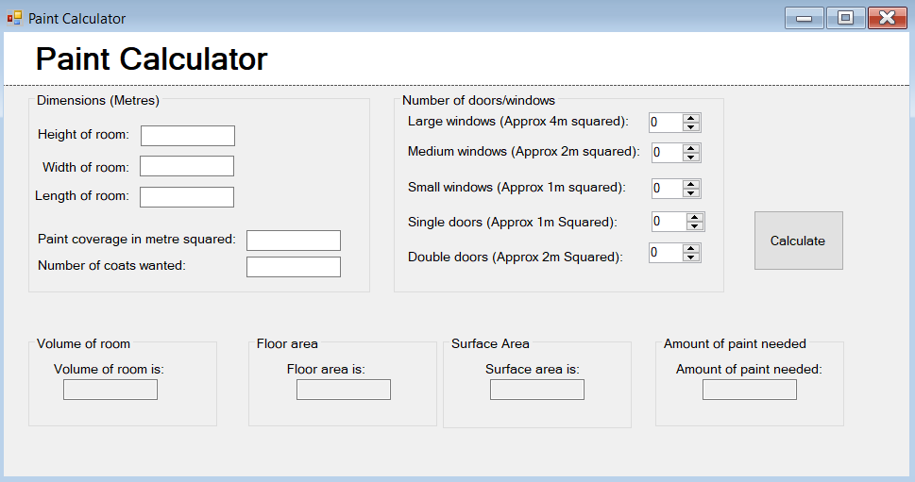

txtHeight - Used to allow the user to input the height of the room.

txtWidth - Used to allow the user to input the width of the room.

txtLength - Used to allow the user to input the length of the room.

txtCoverage - Used to allow the user to input the coverage of the paint they want to use.

txtCoats - Used to allow the user to input the number of coats the user is going to use.

This button will run the calculations and will then display the value in the textboxes.

txtVolume - This will display the volume of the room when the calculate button has been pressed.

txtFloor - This will display the floor area when the calculate button has been pressed.

txtSurface - This will display the wall surface area when the calculate button has been pressed.

txtPaint - This will display the amount of paint needed to paint the walls when the calculate button has been pressed.

nudLrgWindow - Allows the user to select how many large windows they have.

nudMedWindow - Allows the user to select how many medium windows they have.

nudSmlWindow - Allows the user to select how many small windows they have.

nudSinDoor- Allows the user to select how many single doors they have.

nudDblDoor - Allows the user to select how many Double doors they have.

# Flowchart:

User enters room measurements and presses calculate button

Has the user left any textboxes empty?

System runs calculations

A message box shows saying that user has left a measurement out

System shows the results for Volume of room, floor area, surface area and amount of paint needed.

# Test plan:

|  |  |  |  |  |
| --- | --- | --- | --- | --- |
| Test No: | Test description: | Expected Outcome: | Actual Outcome: | Has test failed or passed? |
| 1 | Test if the program can run with no measurements entered in the Height, Width, Length, Paint coverage and Coats needed. | The program will show a message box saying that there are measurements missing. | Program showed a message box saying that there are measurements missing | Test passed |
| 2 | Test if the volume of the room is correct by comparing the result to a calculator. | The value for the volume is the same as using a calculator | The value is correct when compared to a calculator. | Test passed |
| 3 | Test if the floor area of the room is correct by comparing the result to a calculator. | The value for the floor area is the same as using a calculator | The textbox did not show the value once it was calculated | Test failed |
| 4 | Test if the surface area of the walls is correct by comparing the result to a calculator. | The value for the surface area is the same as using a calculator | The value is correct when compared to a calculator. | Test passed |
| 5 | Test if the amount of paint needed to paint the room is correct by comparing the result to a calculator. | The value for the amount of paint needed is the same as using a calculator | The value is correct when compared to a calculator. | Test passed |
| 6 | Test if the user can edit the textboxes for the results. | The program shouldn’t allow the user to edit the result textboxes | The program didn’t allow the user to edit the results textboxes | Test passed |
| 7 | Test if the user can enter a letter or symbol (other than a full stop) in the textboxes. | The program should stop the user from entering a letter or symbol into the textboxes. | The program allowed letters and symbols to be entered in the textboxes | Test failed |

# Failures:

## Test 4:

This was a simple fix because I missed a line of code out which meant the program would not send the floor area value to the textbox. This was fixed by adding a line of code below the calculation for the floor area.

The section of code before the fix was implemented:

The section of code after the fix was implemented:

## Test 7:

This was a failed test because the program didn’t know to check for characters that are not a number, backspace, or a full stop. So, I added some code to the input textboxes that will check for any other characters and if detected it will not insert that character. Below is the fix that was implemented.

